**Women political prisoners arrested by the Indian state**

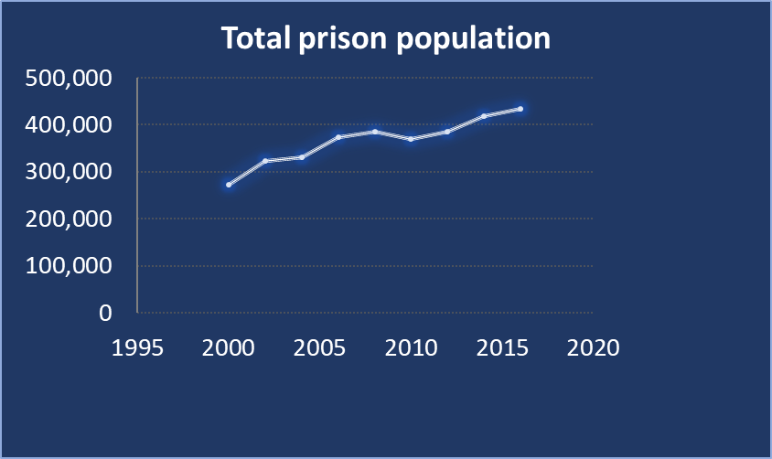The number of people in prisons has seen an increase in India since the year 2002, with about 466,084 detainees in total. Women constitute about 4.1% of those detained and are held in general prisons and a small fraction in segregated women’s only jails. Most prisons are overcrowded and regularly exceed their capacity. According to the National Crime Records Bureau data, the state of Chhattisgarh accounts for the most densely packed prisons for women inmates with an occupancy rate of 66.4% in excess of capacity followed by Uttarakhand exceeding the capacity by 55.3%. This in the regular jails. With respect to women-only jails, the state of West Bengal exceeds capacity with an occupancy rate of 142.04% followed by Maharashtra with an average occupancy rate of 119.85%. The third spot is captured by Bihar with a 115.13 percent average occupancy rate.

*Any attempt to document women political prisoners will always have glaring lapses. There are just too many dispersed in this vast country with diverse political landscape and axes of oppression. There are many whose existence is not known. How does one exist without a name, or in some cases, an entry in a log-book, publicly available? Since 2018, government of India has stopped publishing the National Crime Records Bureau data. Here, we have tried to highlight the names of few nameless and faceless women political prisoners in West Bengal from the original Bengali publication in the outlet: Bandi Sanhati ("Prisoners’ Solidarity").*

*Profile of Four Women Political Prisoners in West Bengal:*  
The demand for the release of political prisoners across India is becoming stronger. About 76 political activists are held in various prisons in West Bengal, Eastern India. Most of them were associated with the historical mass uprising of Nandigram and [Lalgarh](http://sanhati.com/excerpted/1083/). There are also several Maoist political activists directly affiliated with the party who were picked up from various places and are being detained in prisons in West Bengal. Every single one of these prisoners has been languishing in jail for years on end without any trial, for no crime but their political thoughts. A demand for their release must be voiced as well.

**Kalpana Maiti:**

Born to a middle peasant family in Chandrakona Road in West Midnapore, Kalpana was drawn to radical politics in her student life.

By the mid-nineties she had become a full-time political activist working with tribal communities in the hilly but poor Jhargram district in West Bengal, particularly in the villages of Belpahari and Bashpahari. She campaigned for revolutionary politics among the people, helped raise their consciousness regarding their fundamental rights and organized against [state-corporate] extortion and oppression that had been going on for years. She has made significant contributions in building the historic movement of [Jangalmahal.](http://sanhati.com/articles/4045/" \t "_blank) She was the first woman in the West Bengal State Committee of the Communist Party India (Maoists) in 2006.  On December 3, 2010 as she was heading to Kolkata city for her medical treatment, she was arrested by the Special Task Force of the state police from Howrah railway station.

She has been in prison since then. She has been subjected to severe mental torture. One by one, a total of seven cases were imposed on her in three different courts of Kolkata, Midnapore, and Jhargram. She received bail for all cases except the case of an attack on the camp of para-military Eastern Frontier Rifles (EFR) in Silda.  This case is still ongoing, and no one knows when the trial will end.  In 2011, while she was held in the Midnapore jail, Kalpana led a successful movement in demand for distribution of sanitary napkins to all female inmates.

The duress of long-term imprisonment has left marks on the body and psyche of Kalpana. She is currently afflicted by serious medical conditions like diabetes, spondylitis, thyroid malfunction, depression, etc. She is not getting proper medical care in Alipore Jail. Even the minimum rights of a political prisoner are sometimes denied to her and she is forced to take the path of hunger strikes or other protest movements.

**Thakurmoni Murmu:**

The child of a poor tribal family in a remote village of Jhargram, Thakurmoni came in contact with revolutionary politics at a very young age. In the light of her own life experience, she joined the revolutionary party to end exploitation and oppression and became an important part of the guerilla army of people’s liberation. She was instrumental in involving a large number of women in the uprising of Lalgarh. She became a role model to young women in the Jangalmahal.

Right before the 2016 assembly elections, she was arrested along with her life partner, Manasaram Hembram, from a tribal village in the Hooghly district. She was accused in more than 10 cases spanning over Bankura, Purulia, Jhargram, and Kolkata. Apart from a case in the Bankshal courts in Kolkata by the STF, and the Shilda case in Medinipur court, she received bail in all others.

Thakurmoni kept her fighting spirit inside the prison. She continues to struggle to demand for justified rights and dignity for the prisoners. This caused her to receive inhuman torture inside the prison. While in the women’s section of the Alipore jail, in 2017 for the crime of demanding proper food for the prisoners, she was first blamed for illegal use of cell phones. Later, when she was returning from attending the court, in the name of searching, women prison custodians stripped her and inserted fingers in her private parts to search for “illegal objects”. Even under such conditions, Thakurmoni kept resisting. Similar incidence happened again. Due to protests from human rights organizations, she was finally transferred to Dumdum jail.

Before joining politics, Thakurmoni had the opportunity to study till the 8th grade. She decided to appear in the Madhyamik (School final exam) from the Dumdum jail and in 2018, with letter marks (more than 80%) in six subjects she passed with 83% total score. She decided to pursue science for her higher secondary. Immediately the jail authorities blocked her decision. They just will not allow her to study science subjects. Finally, they gave in to her persistence. Thakurmoni got admission in Rabindra Open University. The jail administration is trying their best to not cooperate with her so that she cannot graduate. She is not allowed to take practical classes. She has no teachers, and no reference study materials. In the face of such inadvertence, Thakurmoni is not giving up.

She started a hunger strike demanding for an increase in food allowance during her commute for attendance at the court. To punish her, the jail authorities tried to take away her study desk and chair. They denied permission when friends wanted to gift her a radio for basic entertainment.

**Akka Parobai Patel**

A resident of Telangana, this revolutionary in her mid-forties came to Mumbai for treatment. She was losing her hearing and vision due to thyroid malfunction, along with body balance. She was supposed to undergo surgery at the TATA hospital. Under such conditions, she was arrested by the ATS (MumbaI) on the 29th of February 2012 and implicated in the NIA case, sent to Kolkata. Since then she is in prison. She did not receive any medical treatment. Her conditions have worsened. She cannot move around on her own. There is also a language barrier, as she does not know any other language than Telugu and some bits of Hindi. Since her arrest, she has had no contact with anybody from her family. Her life partner, Chakka Krishna Rao, is imprisoned for life, in another case, in Bhopal jail.

While in the Alipore Jail, in 2017, along with Thakurmoni, Paro Patel received barbaric tortures. While coming back from attendance at the court, this ailing, invalid woman too was stripped naked and in the name of searches, were finger penetrated to find "prohibited objects". As a result of the protests from human rights organizations, she was also transferred to Dumdum jail, where she is currently imprisoned.

**Hirandi Mangal Singh Gaude**

A resident of the Gadchiroli region of Maharashtra, Hirandi was arrested along with her life partner Dinesh Wangkhere by the Mumbai Anti Terror Squad on 29th February 2012. They too were sent to Kolkata after being implicated in the NIA case by the ATS. Since then, she is in prison. Initially she was in Alipore women jail, now she has been shifted to the Dumdum jail.  The trial against her NIA case has not even been initiated. Till today, Hirandi has not met anybody from her family. She is skilled in stitch work. She meets her expenses within the prison with the money she earns doing stitch work. While in Alipore jail, in 2017, along with Thakurmoni and Paro Patel, she was also violated and tortured by the jail authorities.

*Below we include additional profiles of recent arrests of women political prisoners under the draconian Unlawful Activities Prevention Act (UAPA) from different political movements. There has been a steady rise in detentions and arrests under this law since the year 2014. Together with cases pending from previous years, the number of UAPA cases was 5,134 in 2019. This list thus serves as a reminder of the volume of work of documentation of women political prisoners that remains to be done.*

**Jyoti Jagtap**

Jyoti Jagtap is an anti-caste cultural activist associated with Kabir Kala Manch. She was arrested by the Anti-Terrorism Squad (ATS) on 8 September 2020 in the state of Maharashtra. She has been charged with, among other things, sedition, waging war against the government of India, promoting enmity between communities, criminal conspiracy and terrorism-related sections of the UAPA.

**Sudha Bhardwaj**

Sudha Bhardwaj is a human rights lawyer, with a focus on protecting the rights of adivasi (indigenous) people in the state of Chattisgarh. She has acted as legal representation in several cases of extrajudicial executions of adivasis and has represented adivasis and activists before the National Human Rights Commission of India. She also serves as the General Secretary of the Chattisgarh People’s Union for Civil Liberties. She was initially placed under house arrest on August 28th, 2018 and then moved to the Byculla Women's Prison in Mumbai under the Unlawful Activities Prevention Act (UAPA). On 8th of February 2021 a [U.S. digital forensics firm](https://thewire.in/tech/rona-wilson-elgar-parishad-letters-planted-us-firm) reported that the digital evidence (including documents and incriminating letters) used to implicate Sudha Bharadwaj and other activists had been planted.

**Masarat Zahra**

Masarat is a freelance photojournalist from Kashmir and a member of the Network of Women in Media, India (NWMI). She has been covering the situation on the ground in Kashmir for the past four years. She was arrested under the UAPA on April 20, 2020.

**Shoma Sen**

Shoma Sen is a member of Women Against Sexual Violence and State Repression. She has been active with workers’ movement starting from the Mumbai’s 1980s workers strikes and contributed to the Committee for the Protection of Democratic Rights in their work and the publication of their magazine “Adhikar Raksha”. As a student activist she had worked with the Vidyarthi Pragati Sangathana and edited a student magazine called “Kalam”. She was arrested on June 6th, 2018 under the UAPA.

**Gulfisha Fatima**

Gulfisha is a 25 year old student activist from New Delhi. She was actively involved in the women-led protest in Seelampur in North East Delhi against the Citizenship Amendment Act (CAA). She was arrested under the UAPA on April 9, 2020. Though she was granted bail in connection with some cases filed in the Jafrabad Police Station, she remains incarcerated in FIR 59/2020 of the Delhi Police Crime Branch, which invokes the UAPA.

**Annapoorna**

Annapoorna is a labour rights defender, an advocate and an executive member of the Pragatisheela Karmika Samakhya, a workers’ union in the Indian state of Andhra Pradesh. Over the past several years, she has worked with human rights movement in India, advocating for Dalit, women’s and worker’s rights. On 15 December 2020, police personnel arrested woman human rights defender Annapoorna from her house in Vishakapatnam alleging her links to Maoist factions. Annapoorna is currently being detained at the Vishakapatnam Central Jail.

*Postscript: At this moment, Paro Patel and Thakurmoni are back in Alipore jail. Kalpana Maiti is at Dumdum central jail.*